Ideation Phase Empathize C Discover

Date | 4-11-2025
Team ID | NM2025TMID02289
Project Name | Educational Organization Using ServiceNow
Maximum Marks | 4 Marks

Empathy Map in the Ideation Phase
The Empathy Map is a collaborative tool that helps teams gain a deeper understanding of their users. It moves beyond simple demographics to capture what users say, think, do, and feel, thereby building a holistic view of their experience. In the ideation phase, an Empathy Map helps you step into your user's shoes, ensuring that the problems you define and the solutions you generate are truly user-centric and address real needs and pain points.

Components of an Empathy Map
An Empathy Map is typically divided into sections around the user, focusing on four key aspects (sometimes expanded to six):
- SAYS: What does the user say aloud about the problem, their experiences, or solutions? (e.g., "This process is so confusing," "I wish I could do this on my phone," "I just need a quick answer.")
- THINKS: What is the user thinking? What are their motivations, beliefs, fears, hopes, and concerns? (e.g., "Will this affect my grades?", "Am I doing this right?", "I hope this doesn't take too long.") This section might require more inference
based on observations.
- DOES: What actions does the user take? What are their behaviors, routines, or interactions related to the problem? (e.g., "Visits three different websites," "Asks classmates for help," "Gives up after 10 minutes.")
- FEELS: What emotions is the user experiencing? What are their feelings about the situation? (e.g., Frustrated, anxious, overwhelmed, relieved, confused, delighted.)

(Optional additions):
- PAINS: What are the user's biggest frustrations, obstacles, fears, or risks? (This often combines insights from "SAYS," "THINKS," and "FEELS.")
- GAINS: What does the user hope to achieve? What are their desires, needs, or measures of success? (This is the flip side of pains and helps identify opportunities for solutions.)

How to Create an Empathy Map
- Define Your Persona/User: Start by clearly identifying who your specific user is. It's often helpful to work with one persona at a time.
- Gather Data: Base your map on real data from user interviews, surveys,
observations, support tickets, or existing research. Avoid making assumptions.
- Collaborate: As a team, fill out each section of the map, using sticky notes for individual ideas.
- Synthesize: Look for patterns, recurring themes, and surprises across the different sections.

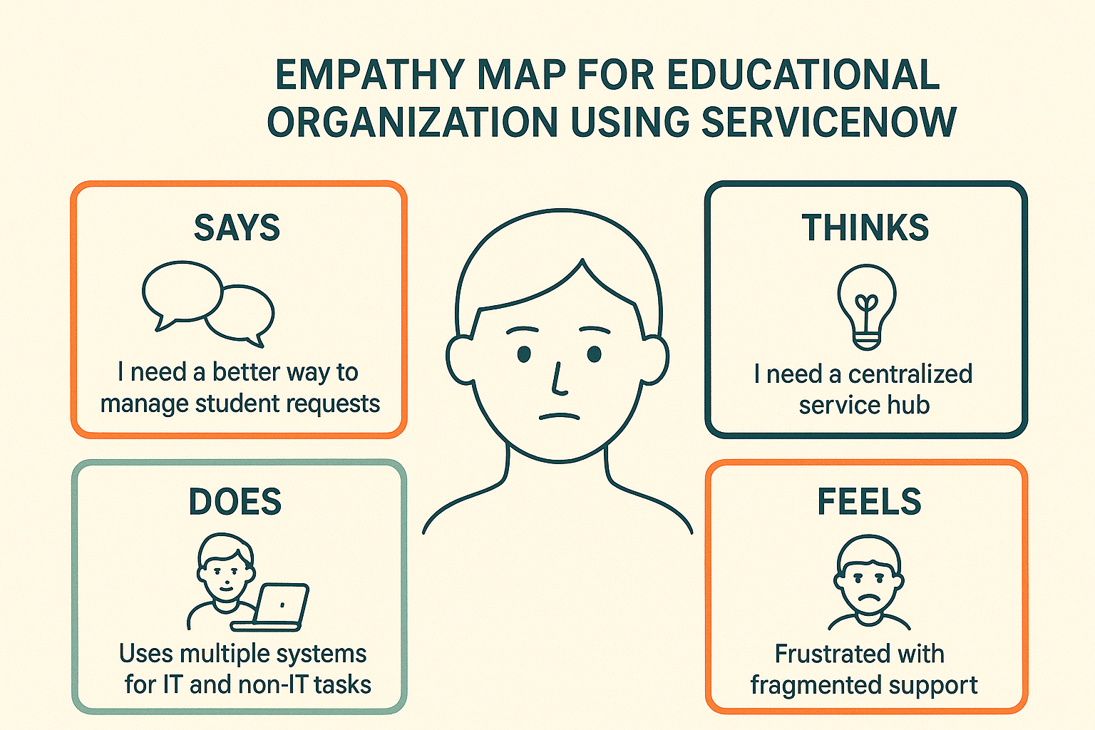

- Identify Insights: From these patterns, derive key insights about the user's needs, motivations, and pain points. These insights often directly inform your problem statements.
- Empathy Maps in an Educational Context (using ServiceNow as a backdrop)
Imagine you're trying to improve the student registration process using ServiceNow. Your user is a "First-Year Student."
  - SAYS: "I can't find the right forms." "Where do I submit this?" "Is this even the correct website?"
  - THINKS: "I hope I don't mess this up." "This is so confusing, everyone else seems to get it." "I wish someone would just tell me what to do."
  - DOES: Jumps between multiple university websites. Calls the registrar's office, gets put on hold. Asks older students for help.
  - FEELS: Overwhelmed, anxious, frustrated, isolated.

